Brindley House Room Hire

Large Training Room and Event Space
We are offering our large training room space for hire at our Brindley House central office and community building. The Diane Stokes Training Room can accommodate 18-20 people board room style, and 30 people theatre style. The room is modern, light and has IT presentation equipment.
- £15 per hour.
- £90 for a full day (9am until 5pm).
- Tea/Coffee and Water Refreshments: £1 per person or £15 unlimited refreshments for a full day group booking.

The room can also be opened up in to a larger space to include a soft seating area and café style tables. This is perfect for a larger event to facilitate a launch, workshop or social activity.
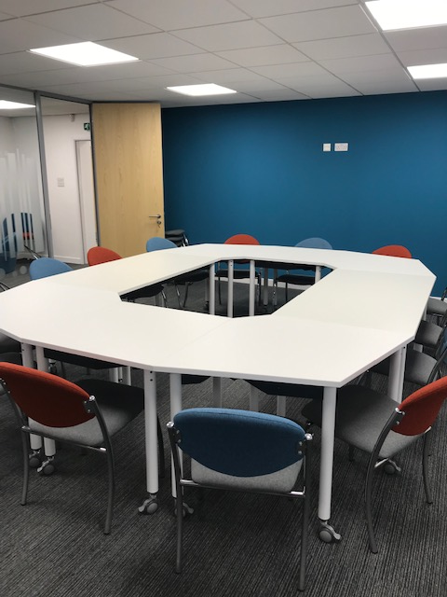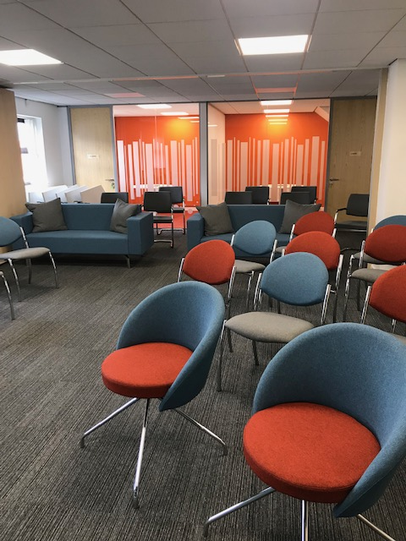
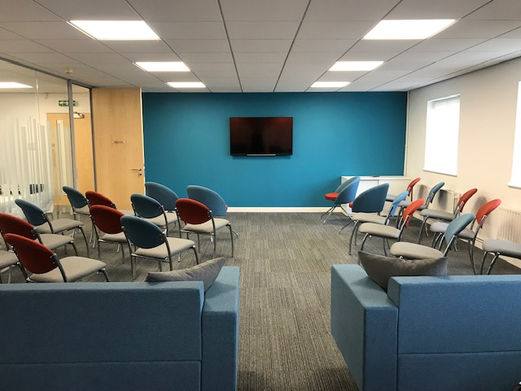

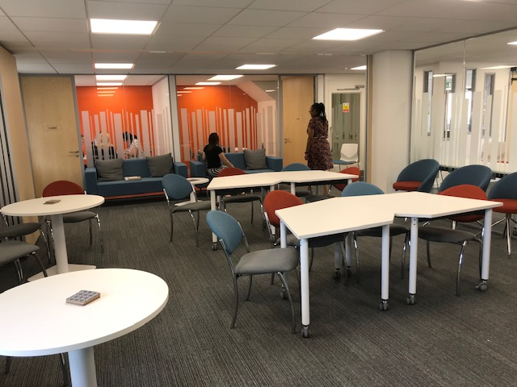

You are welcome to view the room and event space to see the options and possibilities.

Small Meeting Rooms
The Labre and Clarke Rooms are small meeting rooms for up to 4 people, perfect for interviews, counselling or business meetings.
- £7.50 per hour.
- £45 for a full day (9am until 5pm).
- Tea/Coffee and Water Refreshments: £1 per person or £7.50 unlimited refreshments for a full day booking.

Brindley House has ample parking with options for further spaces nearby. We have disabled toilet and baby changing facilities.

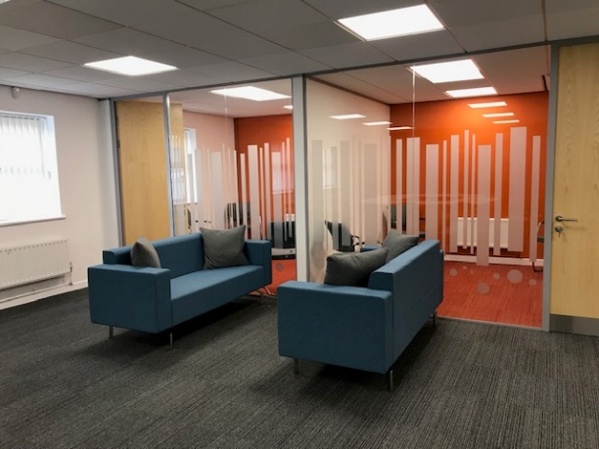

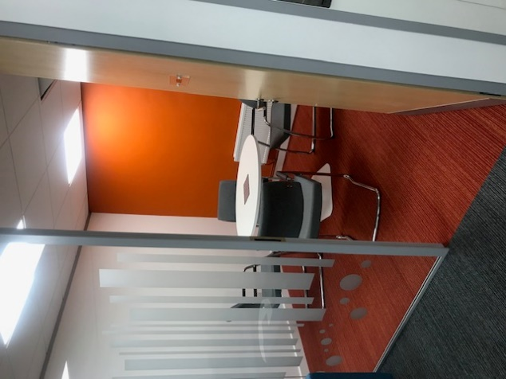

Room hire information is based on office hour availability Mon to Fri. Please contact us for costs and availability for evenings and weekends.
For all enquiries and bookings please email: reception@chadd.org.uk or call 01384 456465.

